**A machine learning approach to the classification of online product reviews**

**Proposed Solution:**

To address this problem, I propose to follow a text classification technique using *NLTK* and *Spacy*. Also I proposed to use *GloveVectorizer* for vectorization and using Random Forest classifier as classifiction algorithm. To improve accuracy stacking multiple models is also an alternative approach.

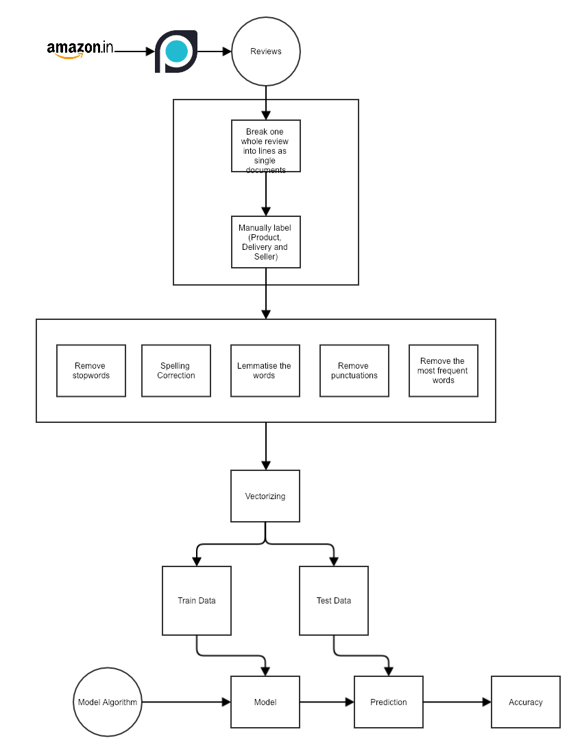

**Evaluation Metrics:**

To evaluate this model, like other classification models, I will consider precision, recall and f1-score for each of the categories. Also, we are considering the results of the work by Abinav Singh et. al.[1] as the benchmark to compare the results.

**References:**

[1] ‘A machine learning approach to product review disambiguation based on function, form and behavior classification’ by Abhinav Sing et. al. (<https://bit.ly/2BKlgmv>)